**SQL PROJECT**

**Topic : Create project table and insert all data.**

**Task :**

1. **Write a query to create a patients table with the fields such as date, patient id, patient name, age, weight, gender, location, phone number, disease, doctor name, and doctor id.**

**Ans : Query**

use project;

create table patients_table(Date varchar(30), pid int, p_name varchar(50), age int, weight int, gender varchar(30),location varchar(50),phone_no bigint, disease varchar(50),doctor_name varchar(50), doctor_id int );

desc patients_table;

**Result :**

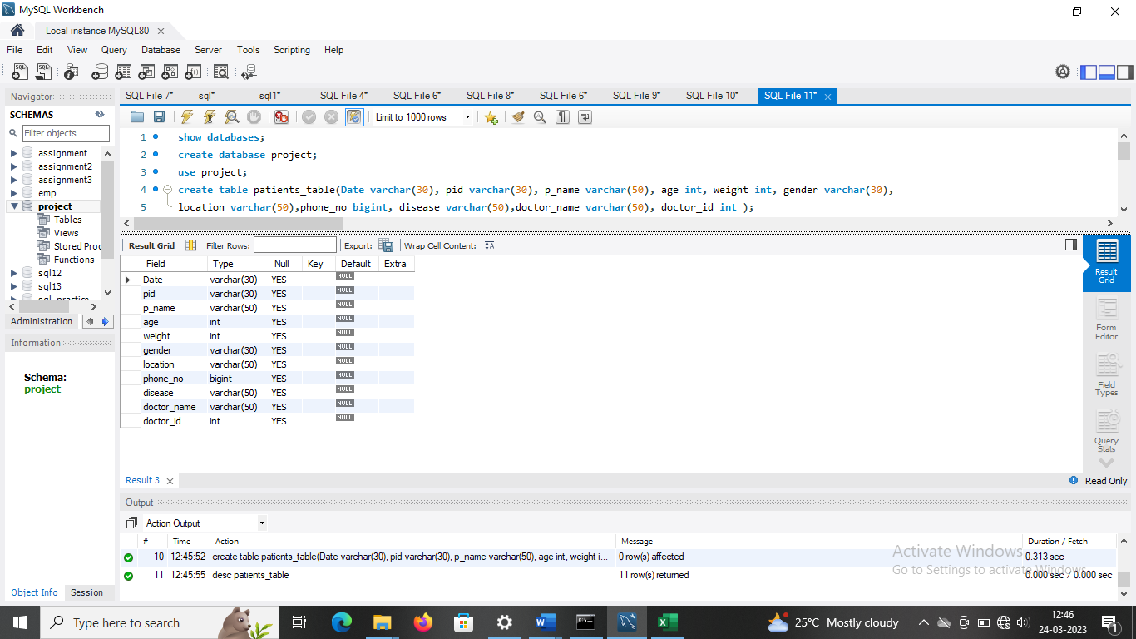

1. **Write a query to insert values into the patients table.**

**Ans : Query**

insert into patients_table(Date,pid,p_name,age,weight,gender,location,phone_no,disease,doctor_name,doctor_id) values

('2014-03-04','AP2021','Sarath',67,76,'Male','Chennai',8975262145,'Cardiac','Mohan',21),

('2019-07-18','AP2022','John',62,80,'Male','Banglore',9702354665,'Cancer','Suraj',22),

('2016-05-02','AP2023','Henry',43,65,'Male','Kerala',9758624583,'Liver','Mehta',23),

('2016-12-24','AP2024','Carl',56,72,'Female','Mumbai',8756954231,'Asthma','Karthik',24),

('2013-03-12','AP2025','Shikar',55,71,'Male','Delhi',9725364867,'Cardiac','Mohan',21),

('2014-12-06','AP2026','Piyush',47,59,'Male','Haryana',9836475982,'Cancer','Suraj',22),

('2017-03-25','AP2027','Stephen',69,55,'Male','Gujarat',7589684215,'Liver','Mehta',23),

('2014-02-28','AP2028','Aaron',75,53,'Male','Banglore',9863452175,'Asthma','Karthik',24);

select* from patients_table;

**Result :**

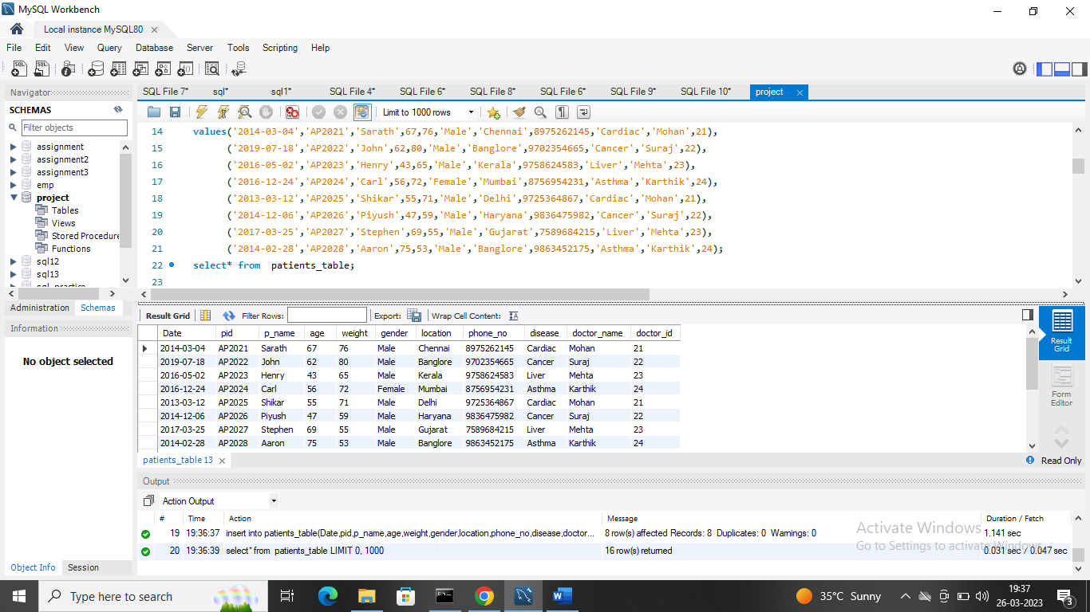

1. **Write a query to display the total number of patients in the table.**

**Ans : Query**

select count(*) from patients_table;

Result :

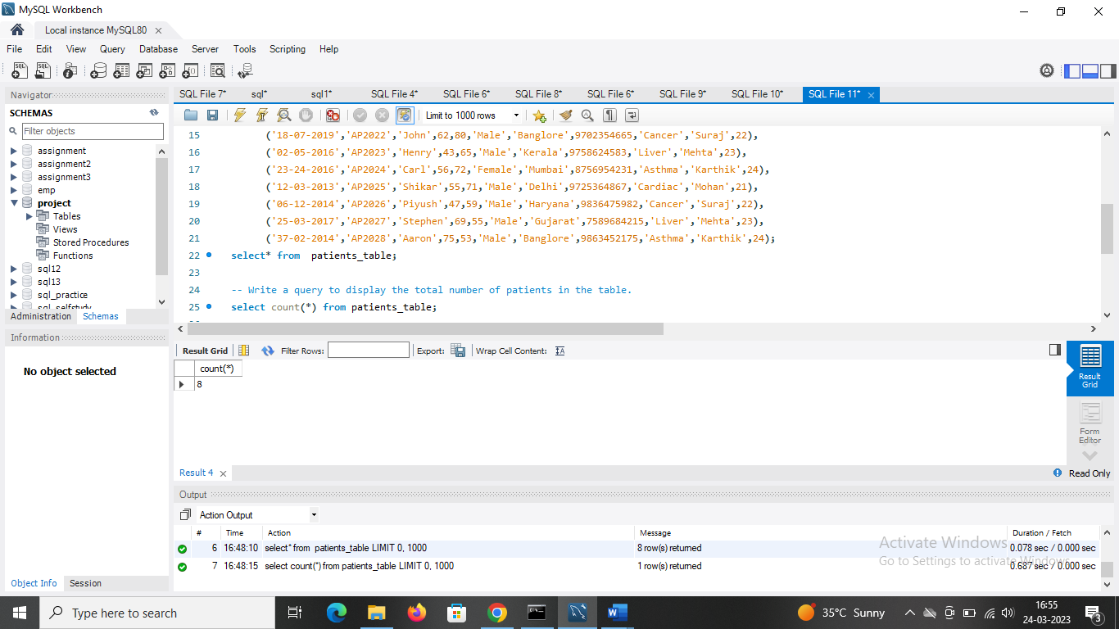

1. **Write a query to display the patient id, patient name, gender, and disease of the patient whose age is maximum.**

**Ans : Query**

select max(age) from patients_table;

select* from patients_table

where age=(select max(age) from patients_table);

**Result :**

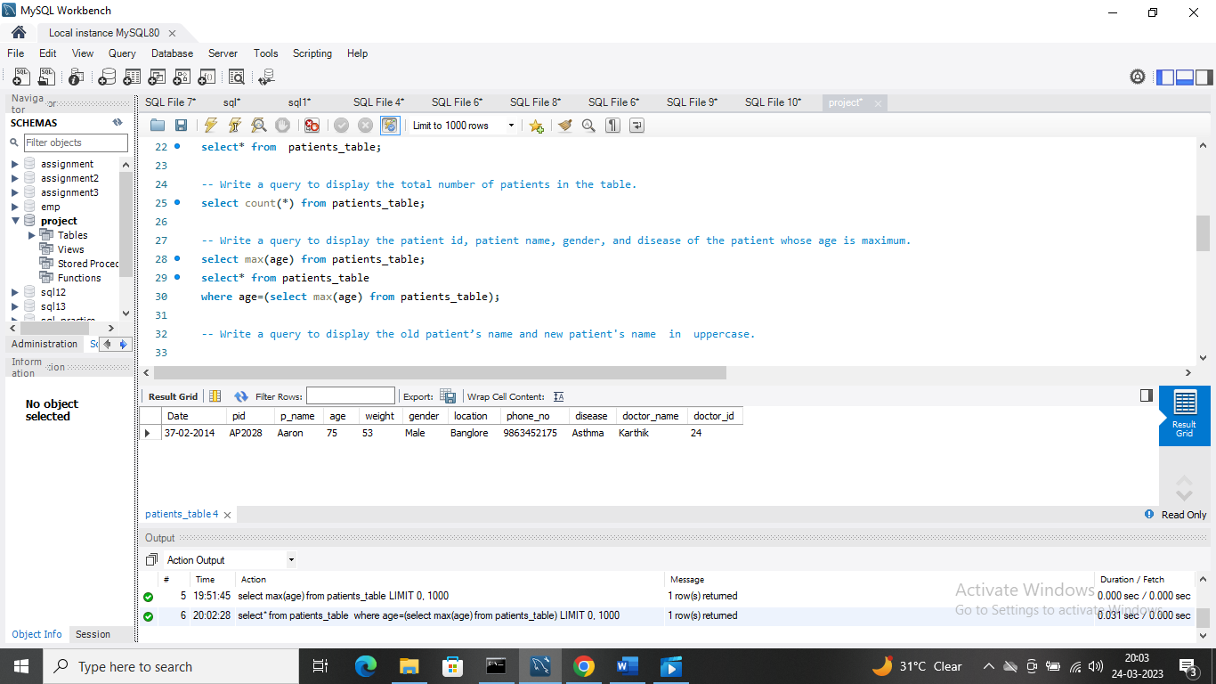

1. **Write a query to display patient id and patient name with the current date.**

**Ans : Query**

select curdate() Date, pid, p_name from patients_table;

**Result :**

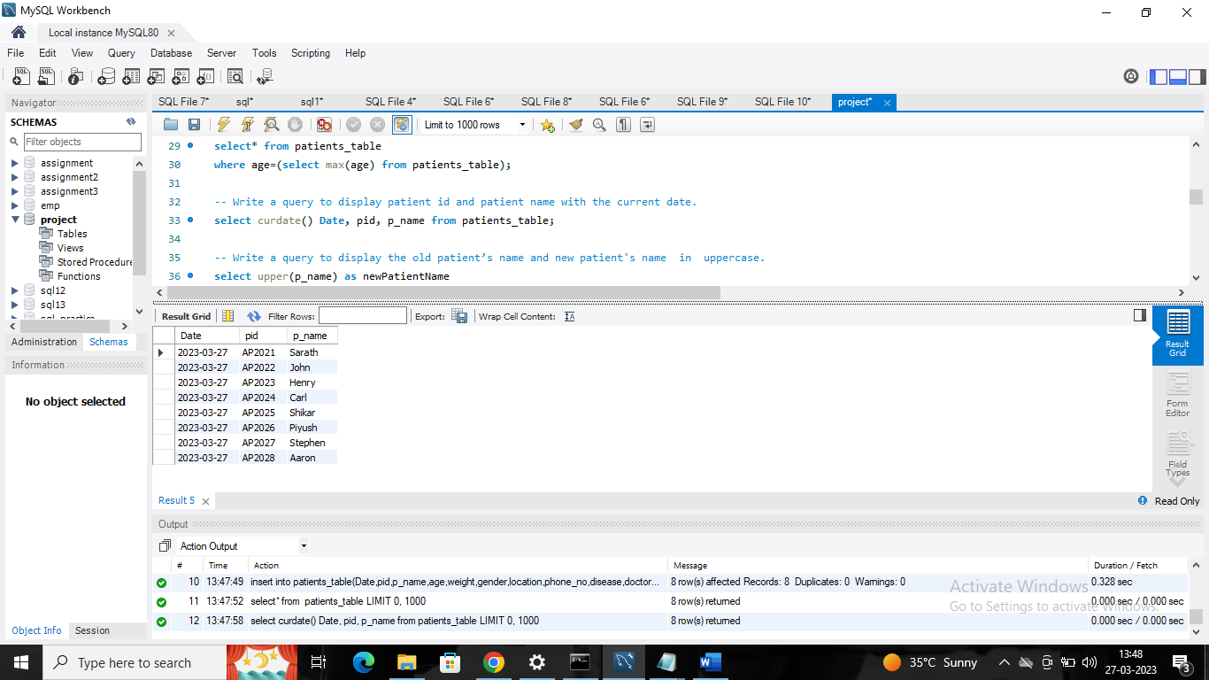

1. **Write a query to display the old patient’s name and new patient's name  in  uppercase.**

**Ans : Query**

select upper(p_name) as newPatientName

from patients_table;

**Result :**

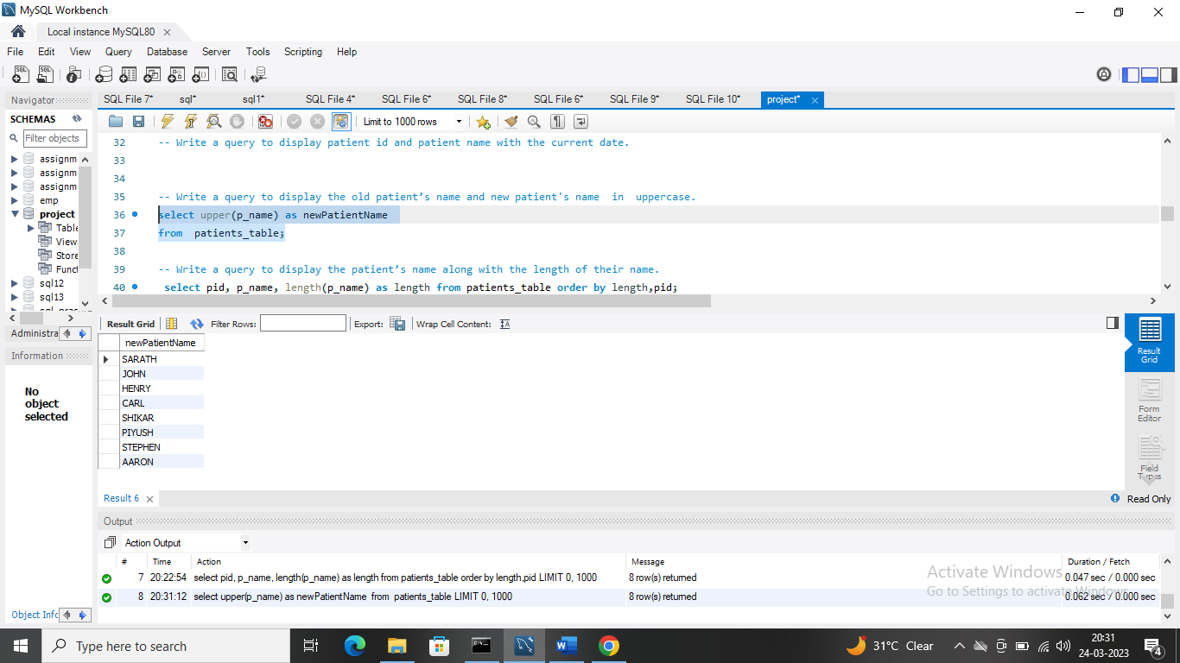

1. **Write a query to display the patient’s name along with the length of their name.**

**Ans : Query**

select pid, p_name, length(p_name) as length from patients_table order by length,pid;

**Result :**

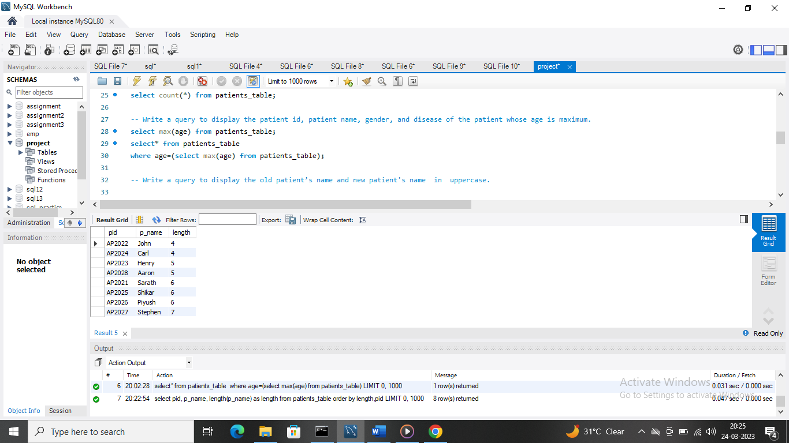

1. **Write a query to display the patient’s name, and the gender of the patient must be mentioned as M or F.**

**Ans : Query**

select p_name,

case when gender ='Male' then 'M' when gender = 'Female' then 'F' else 'Other' end

from patients_table;

**Result :**

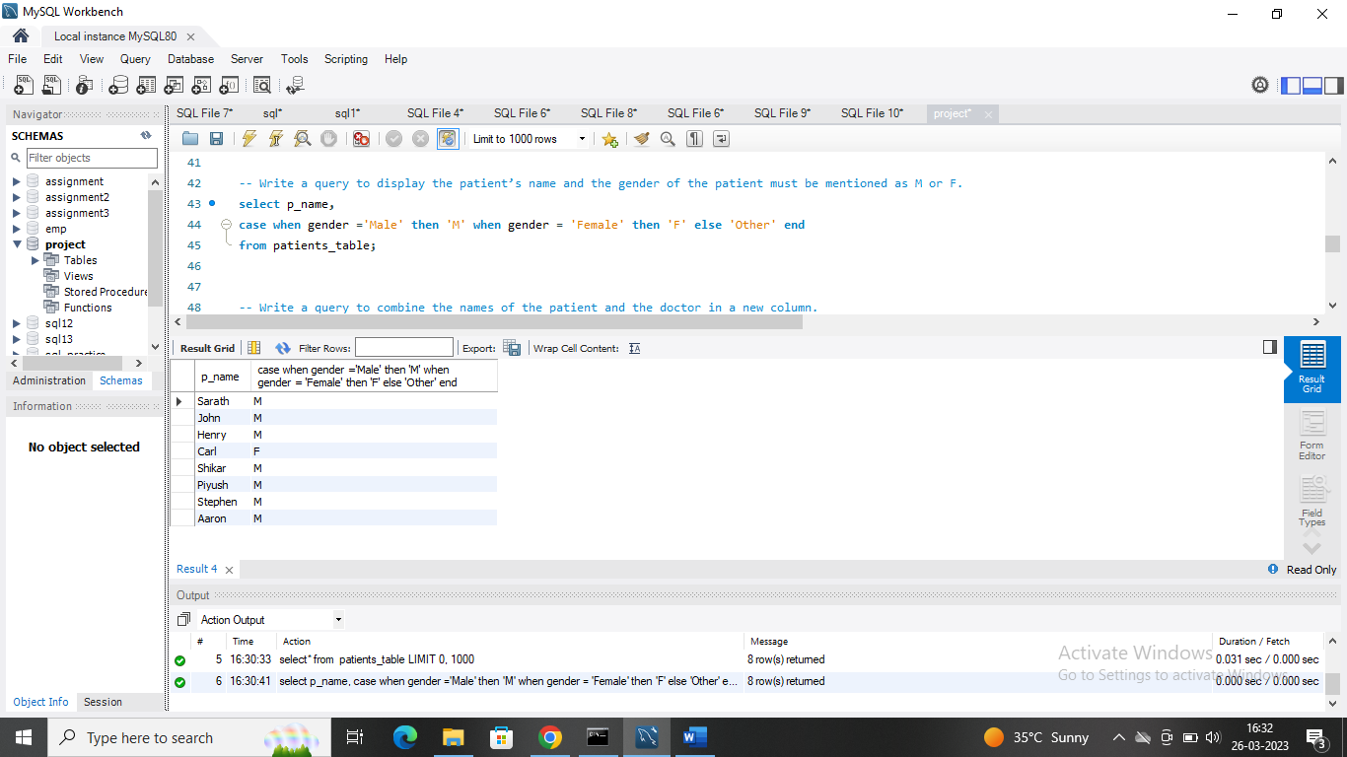

1. **Write a query to combine the names of the patient and the doctor in a new column.**

**Ans : Query**

select CONCAT(p_name , ' ' , doctor_name ) as Name

from patients_table;

**Result :**

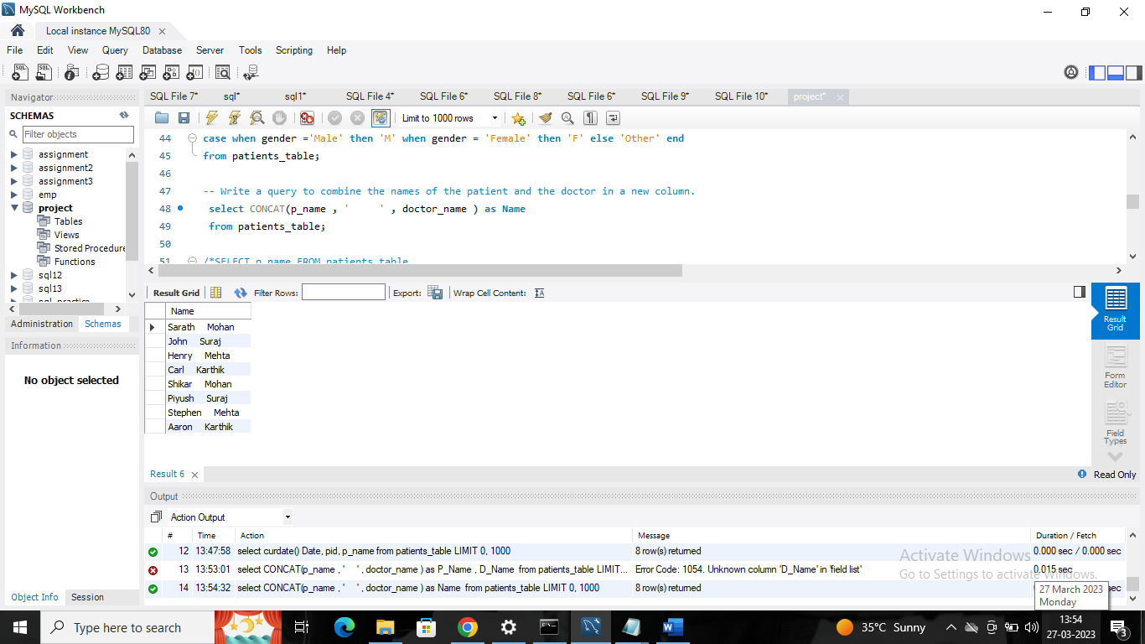

1. **Write a query to display the patients’ age along with the logarithmic value (base 10) of their age.**

**Ans : Query**

select log10(age) from patients_table;

**Result :**

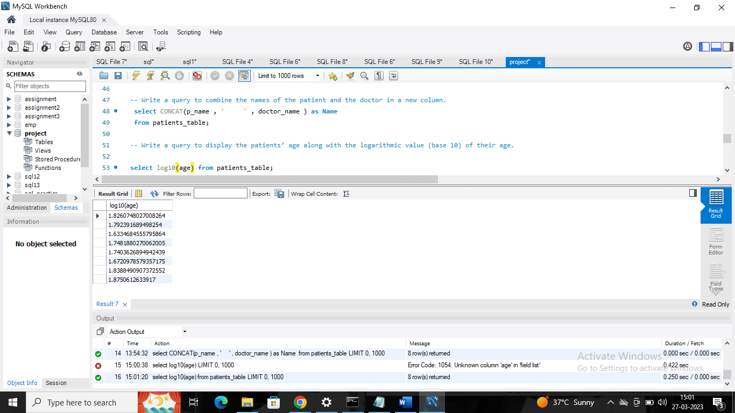

1. **Write a query to extract the year from the given date in a separate column.**

**Ans : Query**

select

extract(year from Date) as year

from patients_table;

**Result :**

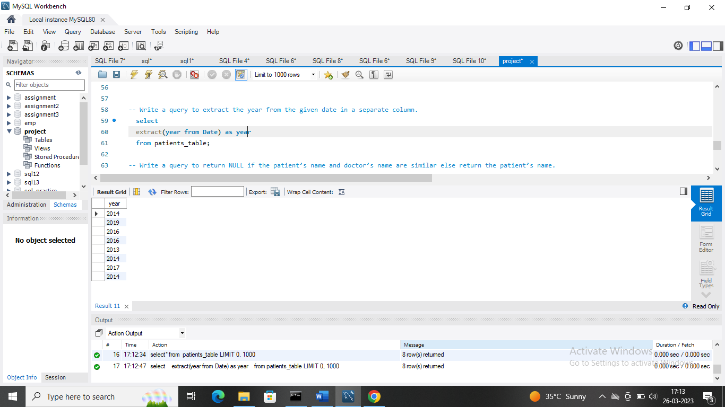

1. **Write a query to return NULL if the patient’s name and doctor’s name are similar  else return the patient’s name.**

**Ans : Query**

select doctor_name

from patients_table

group by doctor_name

having count(*)>1;

**Result :** 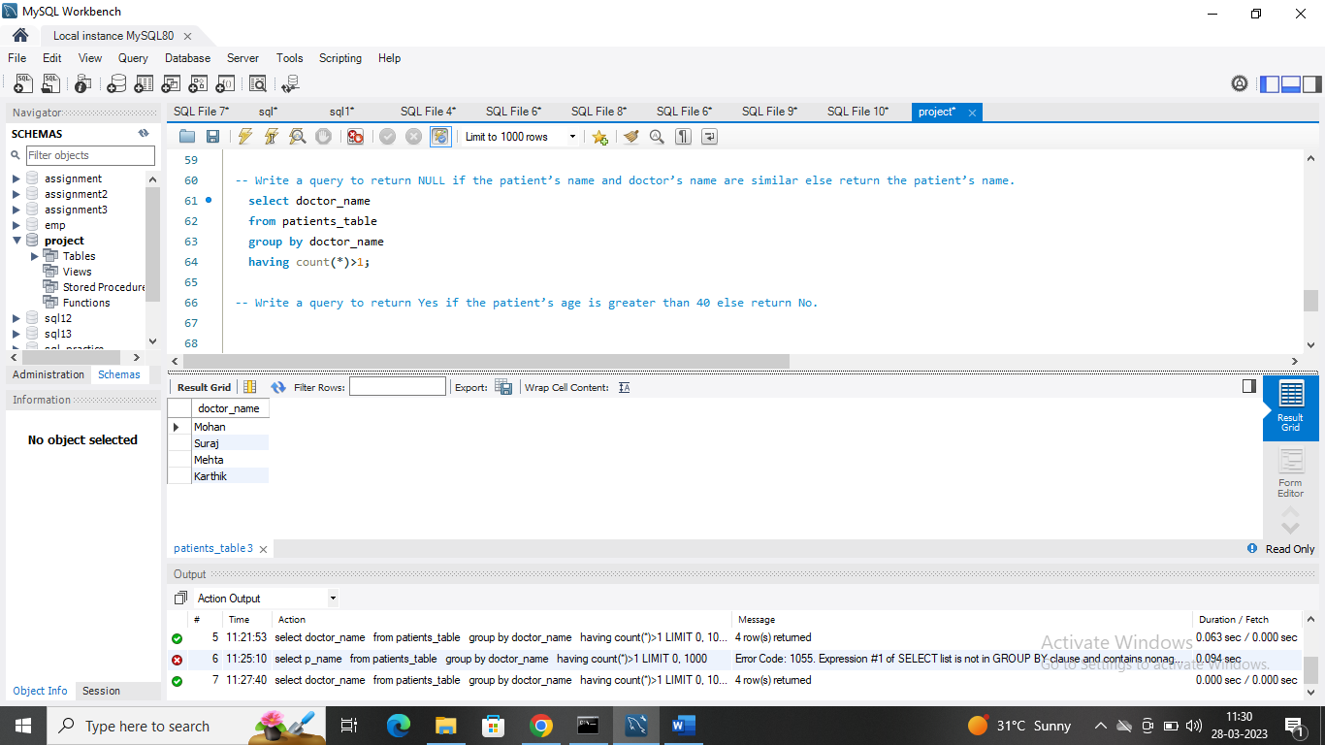

1. **Write a query to display the doctor’s duplicate name from the table.**

**Ans : Query**

select doctor_name,count(*) as occurrence from

patients_table group by doctor_name having count(*)>1;

**Result :**

